2)

a) 1, 2, 3, 4, 5, 6, 7, 8, 9, 10

* Selection Sort:

step0: 1 2 3 4 5 6 7 8 9 10

step1: 1 2 3 4 5 6 7 8 9 10

step2: 1 2 3 4 5 6 7 8 9 10

step3: 1 2 3 4 5 6 7 8 9 10

step4: 1 2 3 4 5 6 7 8 9 10

step5: 1 2 3 4 5 6 7 8 9 10

step6: 1 2 3 4 5 6 7 8 9 10

step7: 1 2 3 4 5 6 7 8 9 10

step8: 1 2 3 4 5 6 7 8 9 10

step9: 1 2 3 4 5 6 7 8 9 10

* Insertion Sort:

step1: 1 2 3 4 5 6 7 8 9 10

step2: 1 2 3 4 5 6 7 8 9 10

step3: 1 2 3 4 5 6 7 8 9 10

step4: 1 2 3 4 5 6 7 8 9 10

step5: 1 2 3 4 5 6 7 8 9 10

step6: 1 2 3 4 5 6 7 8 9 10

step7: 1 2 3 4 5 6 7 8 9 10

step8: 1 2 3 4 5 6 7 8 9 10

step9: 1 2 3 4 5 6 7 8 9 10

step10: 1 2 3 4 5 6 7 8 9 10

* Bubble Sort:

step0: 1 2 3 4 5 6 7 8 9 10

step1:

step1.1: 1 2 3 4 5 6 7 8 9 10

step1.2: 1 2 3 4 5 6 7 8 9 10

step1.3: 1 2 3 4 5 6 7 8 9 10

step1.4: 1 2 3 4 5 6 7 8 9 10

step1.5: 1 2 3 4 5 6 7 8 9 10

step1.6: 1 2 3 4 5 6 7 8 9 10

step1.7: 1 2 3 4 5 6 7 8 9 10

step1.8: 1 2 3 4 5 6 7 8 9 10

step1.9: 1 2 3 4 5 6 7 8 9 10

* Merge Sort:

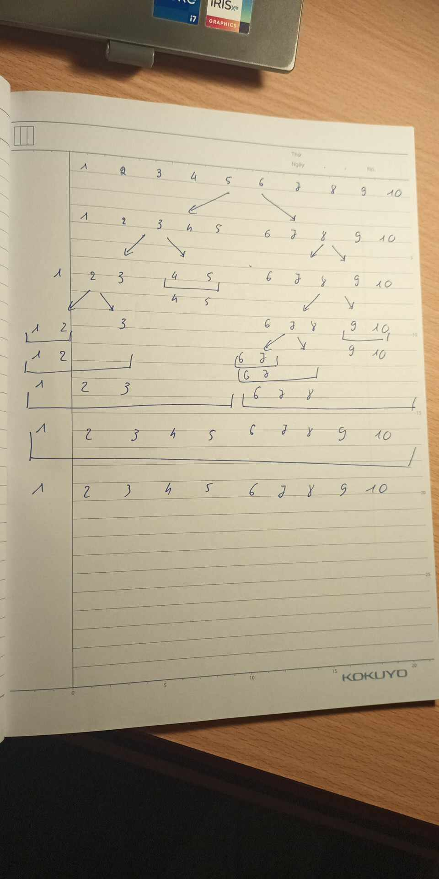

* Quick Sort:
* 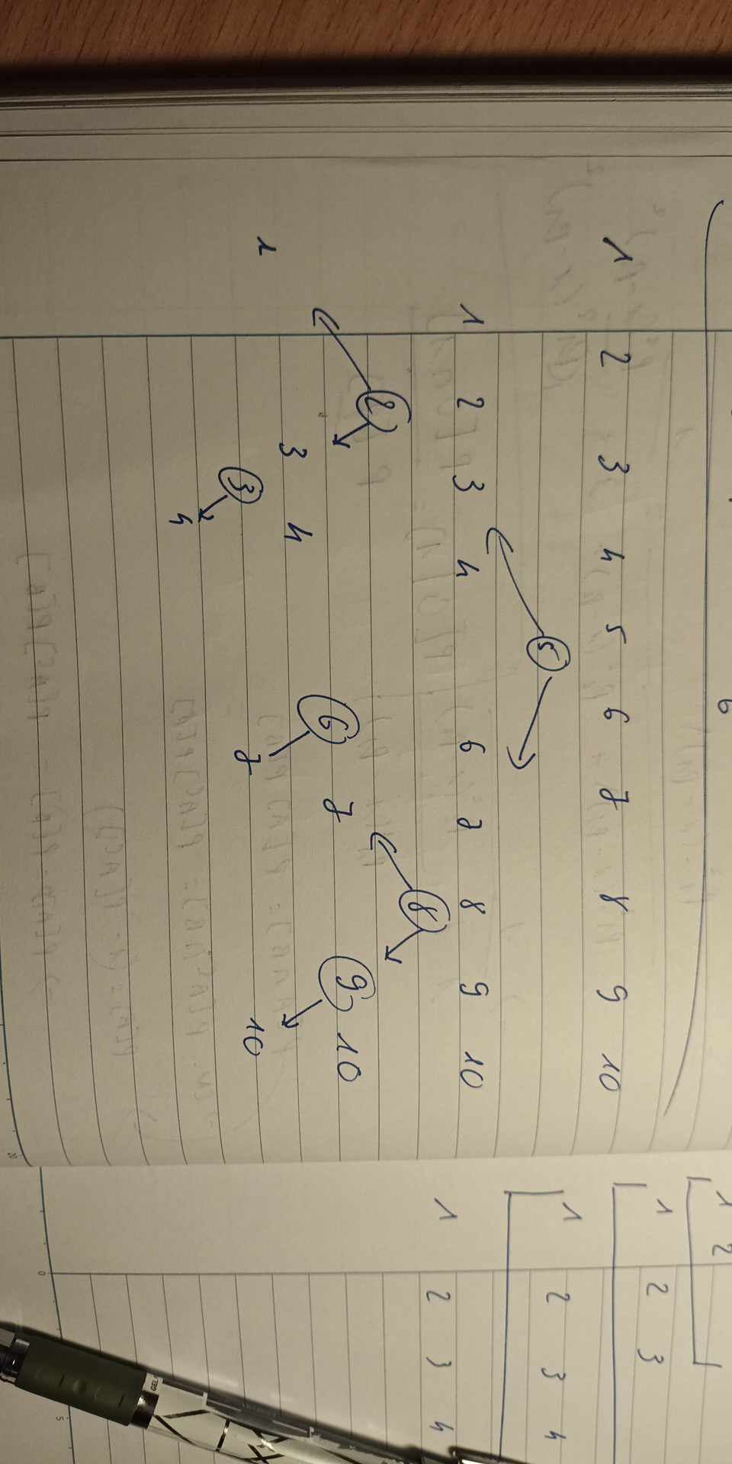  
  b) 10, 9, 8, 7, 6, 5, 4, 3, 2, 1
* Selection Sort:

step0: 10 9 8 7 6 5 4 3 2 1

step1: 1 9 8 7 6 5 4 3 2 10

step2: 1 2 8 7 6 5 4 3 9 10

step3: 1 2 3 7 6 5 4 8 9 10

step4: 1 2 3 4 6 5 7 8 9 10

step5: 1 2 3 4 5 6 7 8 9 10

step6: 1 2 3 4 5 6 7 8 9 10

step7: 1 2 3 4 5 6 7 8 9 10

step8: 1 2 3 4 5 6 7 8 9 10

step9: 1 2 3 4 5 6 7 8 9 10

* Insertion Sort:

step1: 10 9 8 7 6 5 4 3 2 1

step2: 9 10 8 7 6 5 4 3 2 1

step3: 8 9 10 7 6 5 4 3 2 1

step4: 7 8 9 10 6 5 4 3 2 1

step5: 6 7 8 9 10 5 4 3 2 1

step6: 5 6 7 8 9 10 4 3 2 1

step7: 4 5 6 7 8 9 10 3 2 1

step8: 3 4 5 6 7 8 9 10 2 1

step9: 2 3 4 5 6 7 8 9 10 1

step10: 1 2 3 4 5 6 7 8 9 10

* Bubble Sort:

step0: 10 9 8 7 6 5 4 3 2 1

step1:

step1.1: 9 10 8 7 6 5 4 3 2 1

step1.2: 9 8 10 7 6 5 4 3 2 1

step1.3: 9 8 7 10 6 5 4 3 2 1

step1.4: 9 8 7 6 10 5 4 3 2 1

step1.5: 9 8 7 6 5 10 4 3 2 1

step1.6: 9 8 7 6 5 4 10 3 2 1

step1.7: 9 8 7 6 5 4 3 10 2 1

step1.8: 9 8 7 6 5 4 3 2 10 1

step1.9: 9 8 7 6 5 4 3 2 1 10

step2:

step2.1: 8 9 7 6 5 4 3 2 1 10

step2.2: 8 7 9 6 5 4 3 2 1 10

step2.3: 8 7 6 9 5 4 3 2 1 10

step2.4: 8 7 6 5 9 4 3 2 1 10

step2.5: 8 7 6 5 4 9 3 2 1 10

step2.6: 8 7 6 5 4 3 9 2 1 10

step2.7: 8 7 6 5 4 3 2 9 1 10

step2.8: 8 7 6 5 4 3 2 1 9 10

step2.9: 8 7 6 5 4 3 2 1 9 10

step3:

step3.1: 7 8 6 5 4 3 2 1 9 10

step3.2: 7 6 8 5 4 3 2 1 9 10

step3.3: 7 6 5 8 4 3 2 1 9 10

step3.4: 7 6 5 4 8 3 2 1 9 10

step3.5: 7 6 5 4 3 8 2 1 9 10

step3.6: 7 6 5 4 3 2 8 1 9 10

step3.7: 7 6 5 4 3 2 1 8 9 10

step3.8: 7 6 5 4 3 2 1 8 9 10

step3.9: 7 6 5 4 3 2 1 8 9 10

step4:

step4.1: 6 7 5 4 3 2 1 8 9 10

step4.2: 6 5 7 4 3 2 1 8 9 10

step4.3: 6 5 4 7 3 2 1 8 9 10

step4.4: 6 5 4 3 7 2 1 8 9 10

step4.5: 6 5 4 3 2 7 1 8 9 10

step4.6: 6 5 4 3 2 1 7 8 9 10

step4.7: 6 5 4 3 2 1 7 8 9 10

step4.8: 6 5 4 3 2 1 7 8 9 10

step4.9: 6 5 4 3 2 1 7 8 9 10

step5:

step5.1: 5 6 4 3 2 1 7 8 9 10

step5.2: 5 4 6 3 2 1 7 8 9 10

step5.3: 5 4 3 6 2 1 7 8 9 10

step5.4: 5 4 3 2 6 1 7 8 9 10

step5.5: 5 4 3 2 1 6 7 8 9 10

step5.6: 5 4 3 2 1 6 7 8 9 10

step5.7: 5 4 3 2 1 6 7 8 9 10

step5.8: 5 4 3 2 1 6 7 8 9 10

step5.9: 5 4 3 2 1 6 7 8 9 10

step6:

step6.1: 4 5 3 2 1 6 7 8 9 10

step6.2: 4 3 5 2 1 6 7 8 9 10

step6.3: 4 3 2 5 1 6 7 8 9 10

step6.4: 4 3 2 1 5 6 7 8 9 10

step6.5: 4 3 2 1 5 6 7 8 9 10

step6.6: 4 3 2 1 5 6 7 8 9 10

step6.7: 4 3 2 1 5 6 7 8 9 10

step6.8: 4 3 2 1 5 6 7 8 9 10

step6.9: 4 3 2 1 5 6 7 8 9 10

step7:

step7.1: 3 4 2 1 5 6 7 8 9 10

step7.2: 3 2 4 1 5 6 7 8 9 10

step7.3: 3 2 1 4 5 6 7 8 9 10

step7.4: 3 2 1 4 5 6 7 8 9 10

step7.5: 3 2 1 4 5 6 7 8 9 10

step7.6: 3 2 1 4 5 6 7 8 9 10

step7.7: 3 2 1 4 5 6 7 8 9 10

step7.8: 3 2 1 4 5 6 7 8 9 10

step7.9: 3 2 1 4 5 6 7 8 9 10

step8:

step8.1: 2 3 1 4 5 6 7 8 9 10

step8.2: 2 1 3 4 5 6 7 8 9 10

step8.3: 2 1 3 4 5 6 7 8 9 10

step8.4: 2 1 3 4 5 6 7 8 9 10

step8.5: 2 1 3 4 5 6 7 8 9 10

step8.6: 2 1 3 4 5 6 7 8 9 10

step8.7: 2 1 3 4 5 6 7 8 9 10

step8.8: 2 1 3 4 5 6 7 8 9 10

step8.9: 2 1 3 4 5 6 7 8 9 10

step9:

step9.1: 1 2 3 4 5 6 7 8 9 10

step9.2: 1 2 3 4 5 6 7 8 9 10

step9.3: 1 2 3 4 5 6 7 8 9 10

step9.4: 1 2 3 4 5 6 7 8 9 10

step9.5: 1 2 3 4 5 6 7 8 9 10

step9.6: 1 2 3 4 5 6 7 8 9 10

step9.7: 1 2 3 4 5 6 7 8 9 10

step9.8: 1 2 3 4 5 6 7 8 9 10

step9.9: 1 2 3 4 5 6 7 8 9 10

step10:

step10.1: 1 2 3 4 5 6 7 8 9 10

step10.2: 1 2 3 4 5 6 7 8 9 10

step10.3: 1 2 3 4 5 6 7 8 9 10

step10.4: 1 2 3 4 5 6 7 8 9 10

step10.5: 1 2 3 4 5 6 7 8 9 10

step10.6: 1 2 3 4 5 6 7 8 9 10

step10.7: 1 2 3 4 5 6 7 8 9 10

step10.8: 1 2 3 4 5 6 7 8 9 10

step10.9: 1 2 3 4 5 6 7 8 9 10

* Merge Sort:

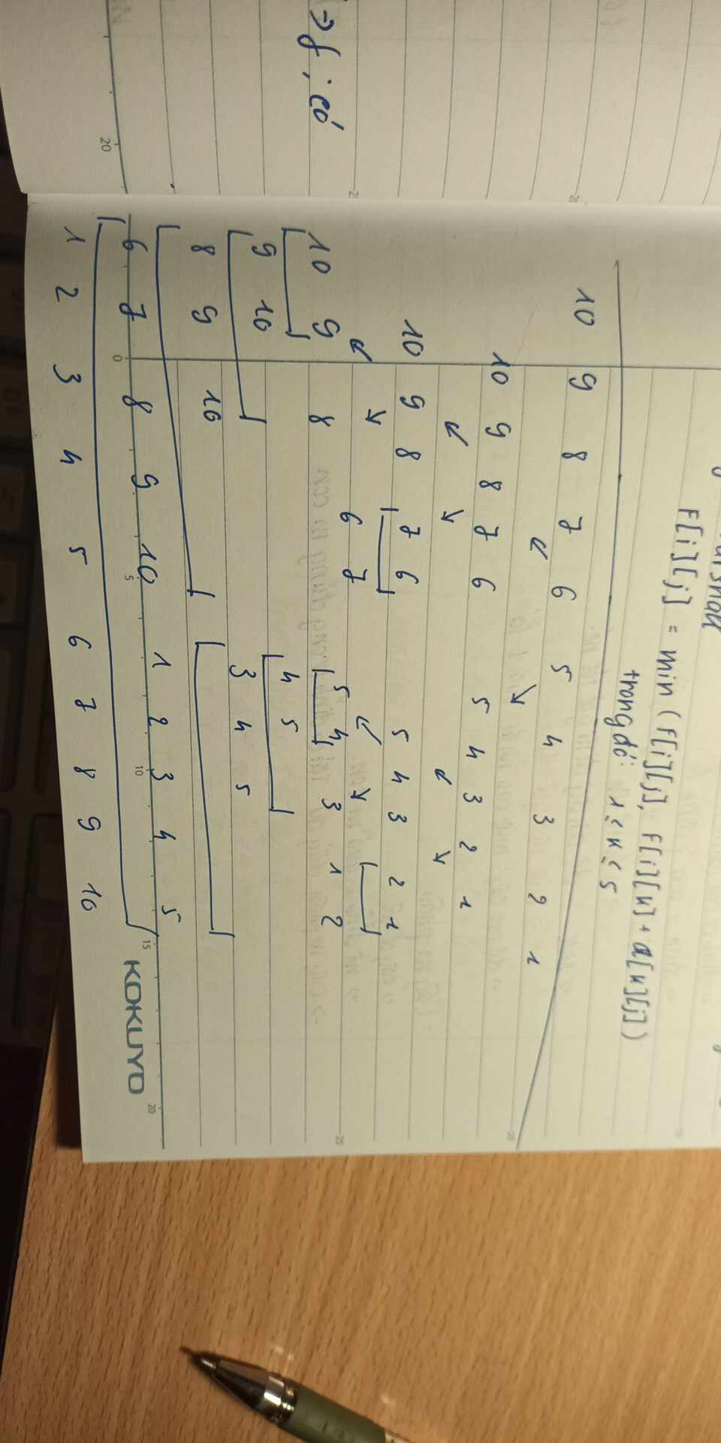

* Quick Sort:

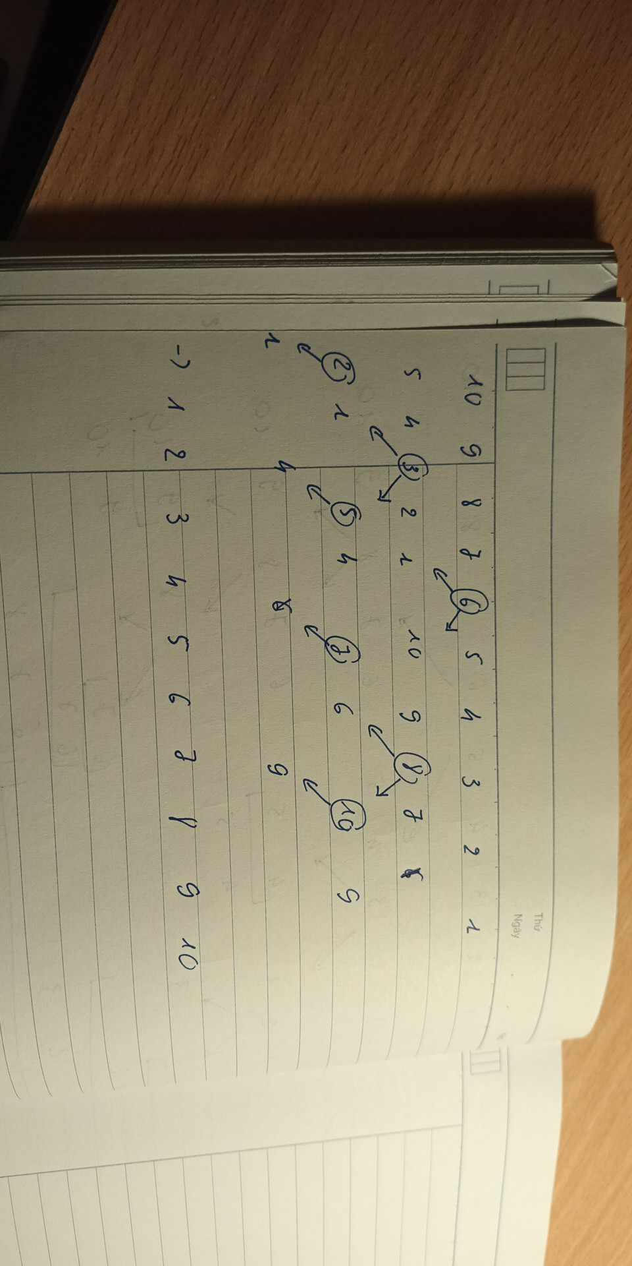

c) 9, 10, 1, 2, 3, 4, 5, 6, 7, 8

* Selection Sort:

step0: 9 10 1 2 3 4 5 6 7 8

step1: 1 10 9 2 3 4 5 6 7 8

step2: 1 2 9 10 3 4 5 6 7 8

step3: 1 2 3 10 9 4 5 6 7 8

step4: 1 2 3 4 9 10 5 6 7 8

step5: 1 2 3 4 5 10 9 6 7 8

step6: 1 2 3 4 5 6 9 10 7 8

step7: 1 2 3 4 5 6 7 10 9 8

step8: 1 2 3 4 5 6 7 8 9 10

step9: 1 2 3 4 5 6 7 8 9 10

* Insertion Sort:

step1: 9 10 1 2 3 4 5 6 7 8

step2: 9 10 1 2 3 4 5 6 7 8

step3: 1 9 10 2 3 4 5 6 7 8

step4: 1 2 9 10 3 4 5 6 7 8

step5: 1 2 3 9 10 4 5 6 7 8

step6: 1 2 3 4 9 10 5 6 7 8

step7: 1 2 3 4 5 9 10 6 7 8

step8: 1 2 3 4 5 6 9 10 7 8

step9: 1 2 3 4 5 6 7 9 10 8

step10: 1 2 3 4 5 6 7 8 9 10

* Bubble Sort:

step0: 9 10 1 2 3 4 5 6 7 8

step1:

step1.1: 9 10 1 2 3 4 5 6 7 8

step1.2: 9 1 10 2 3 4 5 6 7 8

step1.3: 9 1 2 10 3 4 5 6 7 8

step1.4: 9 1 2 3 10 4 5 6 7 8

step1.5: 9 1 2 3 4 10 5 6 7 8

step1.6: 9 1 2 3 4 5 10 6 7 8

step1.7: 9 1 2 3 4 5 6 10 7 8

step1.8: 9 1 2 3 4 5 6 7 10 8

step1.9: 9 1 2 3 4 5 6 7 8 10

step2:

step2.1: 1 9 2 3 4 5 6 7 8 10

step2.2: 1 2 9 3 4 5 6 7 8 10

step2.3: 1 2 3 9 4 5 6 7 8 10

step2.4: 1 2 3 4 9 5 6 7 8 10

step2.5: 1 2 3 4 5 9 6 7 8 10

step2.6: 1 2 3 4 5 6 9 7 8 10

step2.7: 1 2 3 4 5 6 7 9 8 10

step2.8: 1 2 3 4 5 6 7 8 9 10

step2.9: 1 2 3 4 5 6 7 8 9 10

step3:

step3.1: 1 2 3 4 5 6 7 8 9 10

step3.2: 1 2 3 4 5 6 7 8 9 10

step3.3: 1 2 3 4 5 6 7 8 9 10

step3.4: 1 2 3 4 5 6 7 8 9 10

step3.5: 1 2 3 4 5 6 7 8 9 10

step3.6: 1 2 3 4 5 6 7 8 9 10

step3.7: 1 2 3 4 5 6 7 8 9 10

step3.8: 1 2 3 4 5 6 7 8 9 10

step3.9: 1 2 3 4 5 6 7 8 9 10

* Merge Sort:

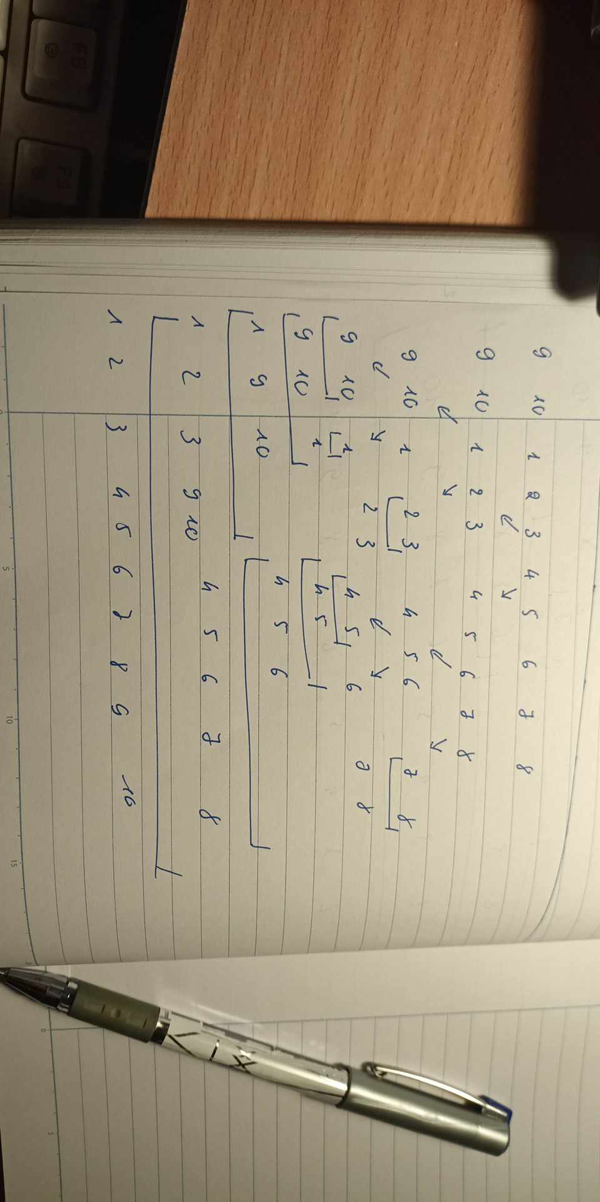

* Quick Sort:

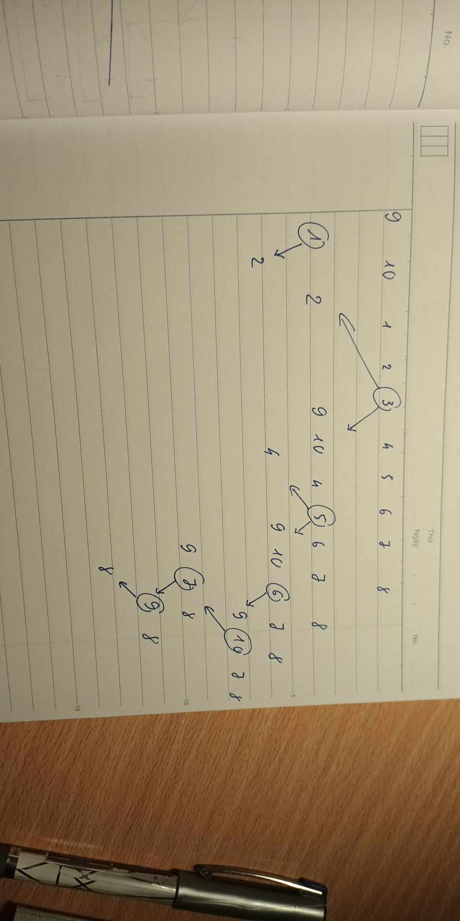

d) 3, 4, 5, 6, 7, 8, 9, 10, 1, 2

* Selection Sort:

step0: 3 4 5 6 7 8 9 10 1 2

step1: 1 4 5 6 7 8 9 10 3 2

step2: 1 2 5 6 7 8 9 10 3 4

step3: 1 2 3 6 7 8 9 10 5 4

step4: 1 2 3 4 7 8 9 10 5 6

step5: 1 2 3 4 5 8 9 10 7 6

step6: 1 2 3 4 5 6 9 10 7 8

step7: 1 2 3 4 5 6 7 10 9 8

step8: 1 2 3 4 5 6 7 8 9 10

step9: 1 2 3 4 5 6 7 8 9 10

* Insertion Sort:

step1: 3 4 5 6 7 8 9 10 1 2

step2: 3 4 5 6 7 8 9 10 1 2

step3: 3 4 5 6 7 8 9 10 1 2

step4: 3 4 5 6 7 8 9 10 1 2

step5: 3 4 5 6 7 8 9 10 1 2

step6: 3 4 5 6 7 8 9 10 1 2

step7: 3 4 5 6 7 8 9 10 1 2

step8: 3 4 5 6 7 8 9 10 1 2

step9: 1 3 4 5 6 7 8 9 10 2

step10: 1 2 3 4 5 6 7 8 9 10

* Bubble Sort:

step0: 3 4 5 6 7 8 9 10 1 2

step1:

step1.1: 3 4 5 6 7 8 9 10 1 2

step1.2: 3 4 5 6 7 8 9 10 1 2

step1.3: 3 4 5 6 7 8 9 10 1 2

step1.4: 3 4 5 6 7 8 9 10 1 2

step1.5: 3 4 5 6 7 8 9 10 1 2

step1.6: 3 4 5 6 7 8 9 10 1 2

step1.7: 3 4 5 6 7 8 9 10 1 2

step1.8: 3 4 5 6 7 8 9 1 10 2

step1.9: 3 4 5 6 7 8 9 1 2 10

step2:

step2.1: 3 4 5 6 7 8 9 1 2 10

step2.2: 3 4 5 6 7 8 9 1 2 10

step2.3: 3 4 5 6 7 8 9 1 2 10

step2.4: 3 4 5 6 7 8 9 1 2 10

step2.5: 3 4 5 6 7 8 9 1 2 10

step2.6: 3 4 5 6 7 8 9 1 2 10

step2.7: 3 4 5 6 7 8 1 9 2 10

step2.8: 3 4 5 6 7 8 1 2 9 10

step2.9: 3 4 5 6 7 8 1 2 9 10

step3:

step3.1: 3 4 5 6 7 8 1 2 9 10

step3.2: 3 4 5 6 7 8 1 2 9 10

step3.3: 3 4 5 6 7 8 1 2 9 10

step3.4: 3 4 5 6 7 8 1 2 9 10

step3.5: 3 4 5 6 7 8 1 2 9 10

step3.6: 3 4 5 6 7 1 8 2 9 10

step3.7: 3 4 5 6 7 1 2 8 9 10

step3.8: 3 4 5 6 7 1 2 8 9 10

step3.9: 3 4 5 6 7 1 2 8 9 10

step4:

step4.1: 3 4 5 6 7 1 2 8 9 10

step4.2: 3 4 5 6 7 1 2 8 9 10

step4.3: 3 4 5 6 7 1 2 8 9 10

step4.4: 3 4 5 6 7 1 2 8 9 10

step4.5: 3 4 5 6 1 7 2 8 9 10

step4.6: 3 4 5 6 1 2 7 8 9 10

step4.7: 3 4 5 6 1 2 7 8 9 10

step4.8: 3 4 5 6 1 2 7 8 9 10

step4.9: 3 4 5 6 1 2 7 8 9 10

step5:

step5.1: 3 4 5 6 1 2 7 8 9 10

step5.2: 3 4 5 6 1 2 7 8 9 10

step5.3: 3 4 5 6 1 2 7 8 9 10

step5.4: 3 4 5 1 6 2 7 8 9 10

step5.5: 3 4 5 1 2 6 7 8 9 10

step5.6: 3 4 5 1 2 6 7 8 9 10

step5.7: 3 4 5 1 2 6 7 8 9 10

step5.8: 3 4 5 1 2 6 7 8 9 10

step5.9: 3 4 5 1 2 6 7 8 9 10

step6:

step6.1: 3 4 5 1 2 6 7 8 9 10

step6.2: 3 4 5 1 2 6 7 8 9 10

step6.3: 3 4 1 5 2 6 7 8 9 10

step6.4: 3 4 1 2 5 6 7 8 9 10

step6.5: 3 4 1 2 5 6 7 8 9 10

step6.6: 3 4 1 2 5 6 7 8 9 10

step6.7: 3 4 1 2 5 6 7 8 9 10

step6.8: 3 4 1 2 5 6 7 8 9 10

step6.9: 3 4 1 2 5 6 7 8 9 10

step7:

step7.1: 3 4 1 2 5 6 7 8 9 10

step7.2: 3 1 4 2 5 6 7 8 9 10

step7.3: 3 1 2 4 5 6 7 8 9 10

step7.4: 3 1 2 4 5 6 7 8 9 10

step7.5: 3 1 2 4 5 6 7 8 9 10

step7.6: 3 1 2 4 5 6 7 8 9 10

step7.7: 3 1 2 4 5 6 7 8 9 10

step7.8: 3 1 2 4 5 6 7 8 9 10

step7.9: 3 1 2 4 5 6 7 8 9 10

step8:

step8.1: 1 3 2 4 5 6 7 8 9 10

step8.2: 1 2 3 4 5 6 7 8 9 10

step8.3: 1 2 3 4 5 6 7 8 9 10

step8.4: 1 2 3 4 5 6 7 8 9 10

step8.5: 1 2 3 4 5 6 7 8 9 10

step8.6: 1 2 3 4 5 6 7 8 9 10

step8.7: 1 2 3 4 5 6 7 8 9 10

step8.8: 1 2 3 4 5 6 7 8 9 10

step8.9: 1 2 3 4 5 6 7 8 9 10

step9:

step9.1: 1 2 3 4 5 6 7 8 9 10

step9.2: 1 2 3 4 5 6 7 8 9 10

step9.3: 1 2 3 4 5 6 7 8 9 10

step9.4: 1 2 3 4 5 6 7 8 9 10

step9.5: 1 2 3 4 5 6 7 8 9 10

step9.6: 1 2 3 4 5 6 7 8 9 10

step9.7: 1 2 3 4 5 6 7 8 9 10

step9.8: 1 2 3 4 5 6 7 8 9 10

step9.9: 1 2 3 4 5 6 7 8 9 10

* Merge Sort:

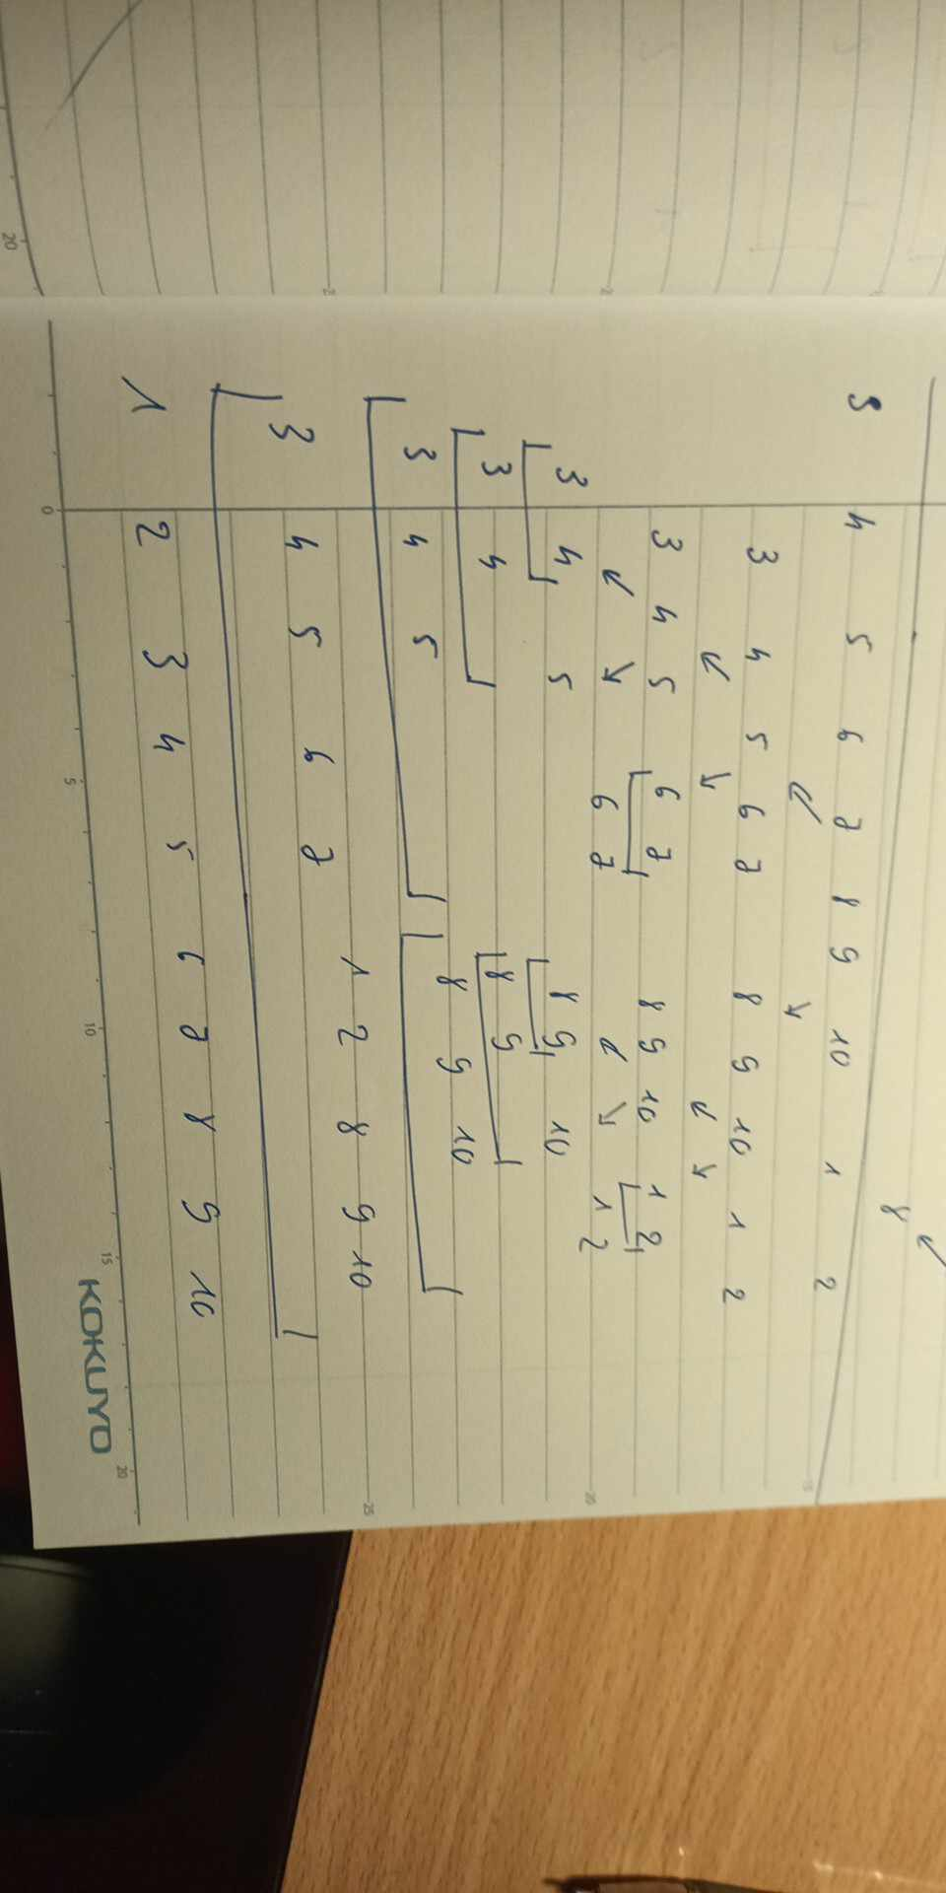

* Quick Sort:

